Firstly open the Arduino IDE  
  
Go to files and click on the preference in the Arduino IDE

[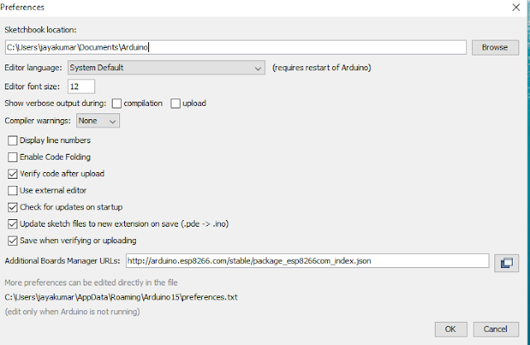](http://1.bp.blogspot.com/-OV1A_EMzm00/VnPsxvqxr_I/AAAAAAAAAuI/qlswMsf3Reo/s1600/preference.PNG)

copy the below code in the Additional boards Manager  
  
http://arduino.esp8266.com/stable/package_esp8266com_index.json  
  
click OK to close the preference Tab.

[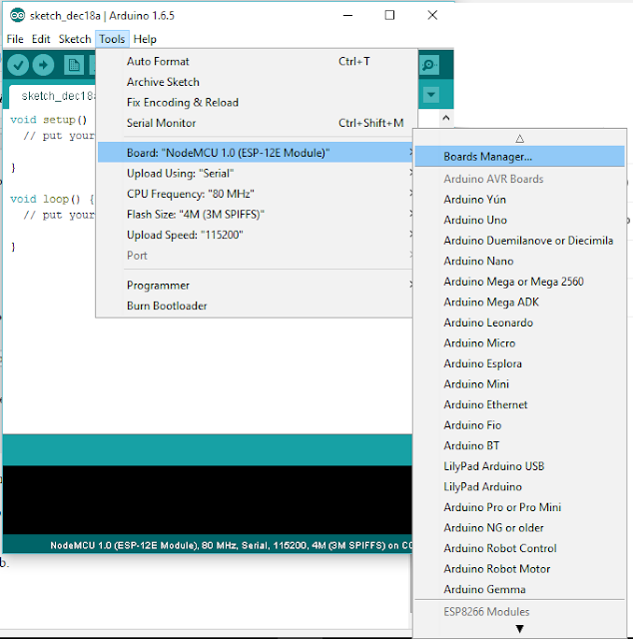](http://1.bp.blogspot.com/-u-opNqS4BiI/VnPuR5Pc5uI/AAAAAAAAAuU/wGg5PkYGE3M/s1600/board%2Bmanager.png)

After completing the above steps , go to Tools and board, and then select board Manager

[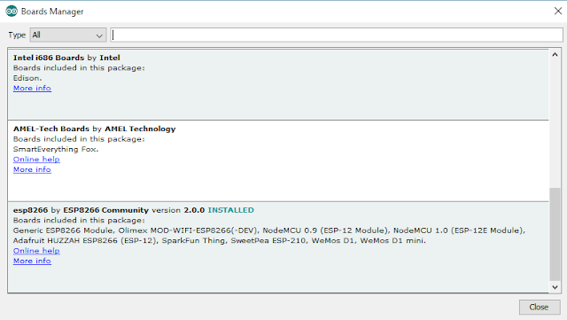](http://1.bp.blogspot.com/-njmbyb_yr_U/VnPuv7WAjRI/AAAAAAAAAus/nj0gR7SyFuE/s1600/board%2Bmanager%2Bopen.PNG)

Navigate to esp8266 by esp8266 community and install the software for Arduino.  
  
Once all the above process been completed we are read to program our esp8266 with Arduino IDE.  
  
  
  
[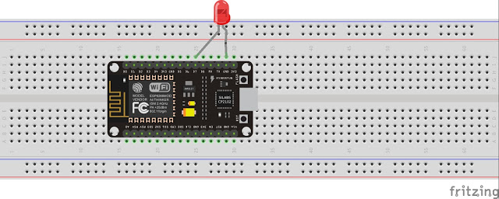](http://3.bp.blogspot.com/-qYY0XGJiYFo/VnPwPEkNq9I/AAAAAAAAAu4/NPbST-BezFY/s1600/blink_bb.jpg)  
  
  
  
  
  
  
  
  
  
  
  
  
  
  
  
For this example I have used NodeMCU esp8266 and if you are using any other vendor wifi chips or generic wifi module please check with the esp8266 Pin mapping which is very essential to make things works.